* Electronic mail
  + Three major components
    - User agents
      * “Mail reader”
      * Composing, editing, reading, mail messages
      * Ex: Outlook
      * Outgoing,incoming messages stored on server.
    - Mail servers
      * Mailbox contains incoming messages for user
      * Message queue of outgoing (to be sent) mail messages
      * SMTP protocol between mail servers to send messages
        + Client: sending mail server
        + Server: receiving mail server
    - Simple mail transfer protocol (SMTP)
      * Uses TCP to reliable transfer email message from client to server, port 25
      * Direct transfer: sending server to receiving server
      * Three phases of transfer:
        + Handshaking
        + Transfer of messages
        + Closure
      * command/response interaction like HTTP
        + Commands: ASCII text
        + Response: status code and phrase
      * Messages must be in 7-bit ASCII
    - SMTP
      * Uses persistent connections : can send multiple messages on a connection
      * SMTP requires message (header and body) to be in 7-bit ASCII
      * SMTP server ses CRLF.CRF to determine end of message
    - HTTP vs SMTP:
      * HTTP: pull
      * SMTP: push
      * Both have ASCII command/response interaction, status code
      * HTTP: each object encapsulated in its own response message
      * SMTP: multiple objects sent in multipart message

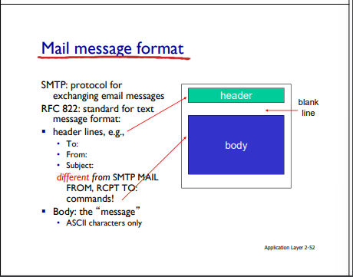

* SMTP
  + delivery/storage to receiver’s server
* Mail access protocol: retrieval from server
  + POP: post office protocol: authorization,download
  + IMAP: Internet Mail Access Protocol: more features, including manipulation of stored messages on server
  + HTTP: gmail,hotmail,yahoo! Mail
* POP3
  + Download and delete mode
    - Cannot re-read email if he changes client
  + Download and keep : copies of messages on different clients
  + POP3 is stateless across sessions
* IMAP
  + Keep all messages in one place : at server
  + Allows user to organize messages in folder
  + Keeps user state across sessions
    - Names of folders and mappings between message IDs and folder name.
* Domain Name System(DNS)
  + Internet hosts,routers
    - IP address(32 bit) - used for addressing datagrams
    - Name - ex: yahoo.com
      * Used by humans
  + DNS
    - Distributed database - implemented in hierarchy of any **name servers**
    - **Application-layer protocol**: hosts,name servers communicate to resolve names(address/name translation)
  + DNS Services
    - Hostname to IP address translation
    - Host aliasing
      * Canonical, alias names
      * Mail serer aliasing
      * Load distribution
        + Replication Wed servers: many IP addresses correspond to one name
    - Centralize DNS?
      * NO
      * Single point of failure
      * High traffic volume
      * Distant centralized database
      * Maintenance
  + DNS: distributed, hierarchical
    - 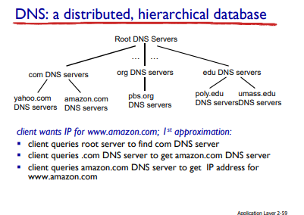
  + DNS: root name servers
    - Contacted by local name server that can not resolve name
    - Root name server:
      * Contacts authoritative name serve rif anime mapping not known
        + Gets mapping
        + Returns mapping to local name server
  + Top-level domain(TLD) servers:
    - Responsible for com,org,net,edu,aero,jobs,museums,and all top-elvel country domains, e.g. uk,fr,ca,jp
    - Network Solutions maintains severs for .com TLD
    - Educause for .edu TLD
  + Authoritative DNS Servers:
    - Organization’s own DNS Servers, providing authoritative hostname to IP mapping for organization's name hosts
    - Can be maintained by organization or service provider
  + Local DNS Name Server
    - Does not strictly belong to hierarchy
    - Each ISP(residential,company,university0 has one
      * Default name server
    - When host makes DNS query, query is sent to its local DNS server
      * Has local cache of recent name-to-address translation pairs
      * Acts as proxy, forwards to query into hierarchy
  + DNS name resolution
    - Iterated query
      * Contacted server replies with name of server to contact
    - Recursive query:
      * Puts burden of name resolution on contacted name server
      * Heavy load at upper levels of hierarchy
  + DNS Caching
    - Once any name server learns mapping, it caches mapping
      * Cache entries timeout (disappear) after some time(TTL)
      * TLD servers typically caches in local name servers
    - Cached entries may be out of date
  + DNS Records
    - 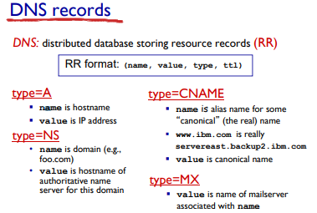
  + DNS Protocol, messages
    - Query and reply messages, both with same message format
    - Message header
      * Identification: 16 bit # for query, reply to query uses same #
      * Flags
        + Query or reply
        + Recursion desired
        + Recursion available
        + Reply is authoritative
* Peer to Peer - P2P
  + Pure P2P Architecture
    - No always-on server
    - Arbitrary end systems directly communicate
    - Peers are intermittently connected and change IP addresses
    - ***Everyone can be a server
    - Ex: BitTorrent(file distribution), Streaming(KanKan), VoIP(skype)
  + Peer upload/download capacity is limited resource
  + File distribution time: client-server
    - Server transmission: must sequentially send(upload) N files
    - Time to send one copy: F/us
    - Time tos end N copies : NF/us
    - client : each client must download file copy
      * dmin=min client download rate
      * Min client download time: F/dmin
    - 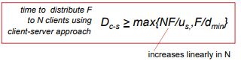
  + File distribution time: P2P
  + 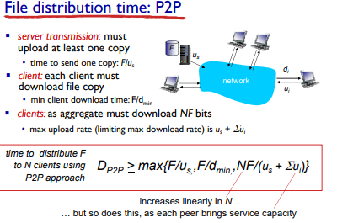
    - Server transmission: must upload at least one copy